Coffee Chain Sales & Profit Analysis
(Tableau)

Business Question 1: Which markets generate the most revenue, profit, and order volume?
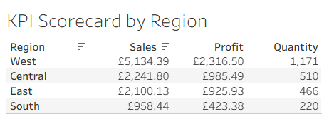
Overall, the West region performed the strongest across Coffee Chain’s key performance indicators. It generated the highest sales, profit and quantity sold, showing that it is the leading region for both revenue and order volume. This suggests that the West region is a key driver of business performance and could be used as a benchmark when reviewing weaker-performing regions.

Business Question 2: Which regions are above/below the company average and the sales target?
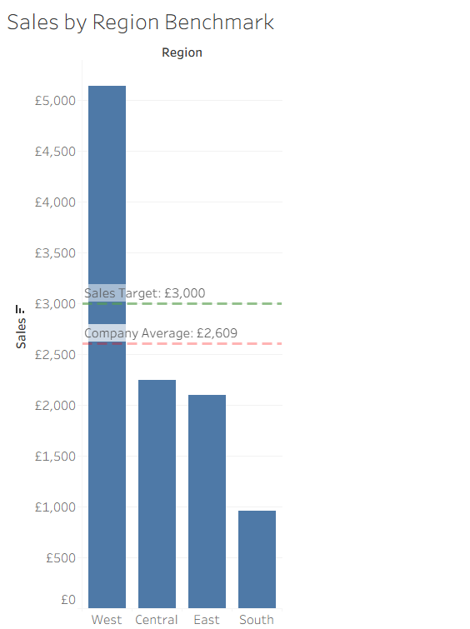

West is the only region performing above both the company average sales value of £2,609 and the assumed sales target of £3,000. Central, East and South all fall below both benchmarks, suggesting that sales performance is heavily concentrated in the West region. As no target value was provided in the brief, a £3,000 target was used as a benchmark to compare regional performance.

Business Question 3: Which products drive the most profit across the business?

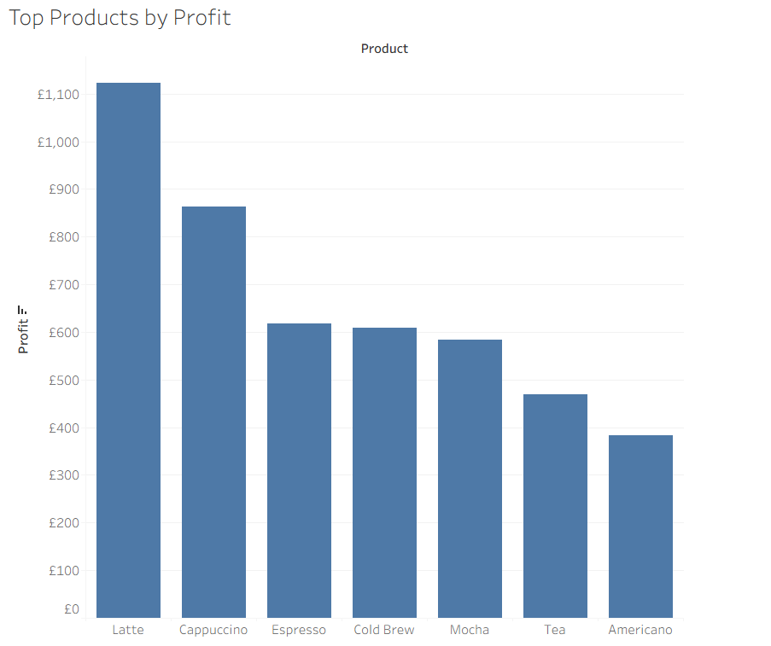

Latte generated the highest profit, making it the strongest-performing product in the analysis. Cappuccino and Espresso also contributed strongly, while Americano produced the lowest profit among the products shown. Although the brief requested a Top 10 set, the dataset only contains seven product categories, so all available products are displayed using the Top 10 Products by Profit set.

Business Question: Is Coffee Chain on a growth or decline trajectory?
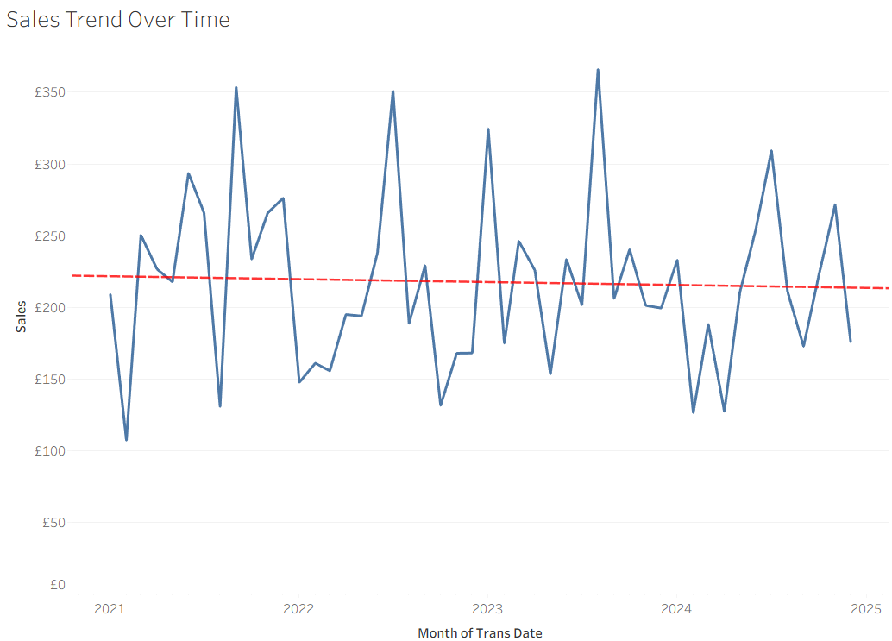

Coffee Chain’s sales show regular month-to-month fluctuations, with several peaks and dips across the period. However, the linear trend line is mostly flat with a slight downward slope, suggesting that overall sales are not showing sustained growth. This indicates that Coffee Chain may need to investigate what is causing sales volatility and identify opportunities to improve future performance.

Business Question: What are the expected sales for the next six months, and how confident are we?

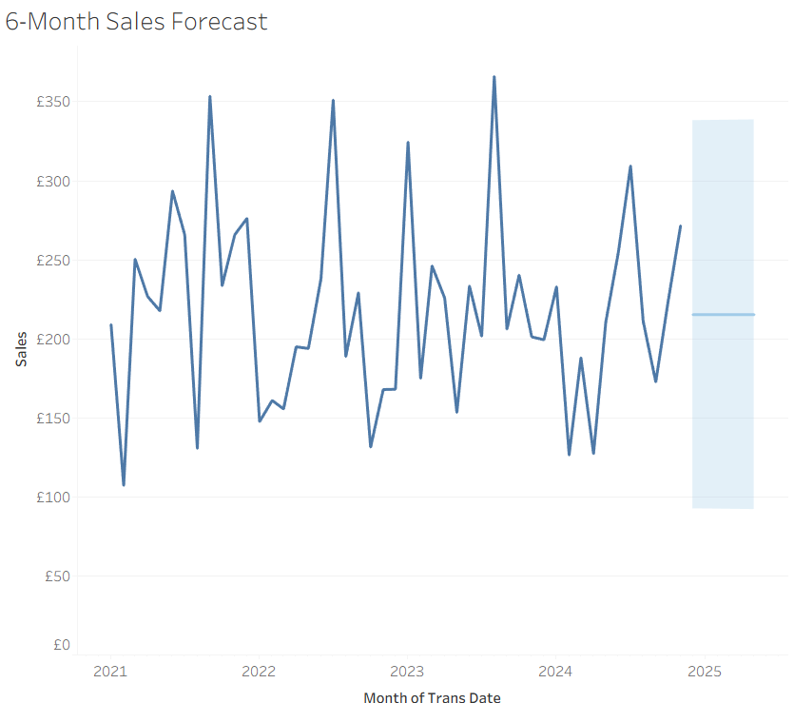

The six-month forecast suggests that Coffee Chain’s sales are expected to remain relatively stable, with forecasted sales sitting around the £200–£220 range. However, the confidence band is quite wide, showing a high level of uncertainty in the forecast. This is likely due to the frequent peaks and dips in historical sales, meaning future performance should be treated as an estimate rather than a precise prediction.

